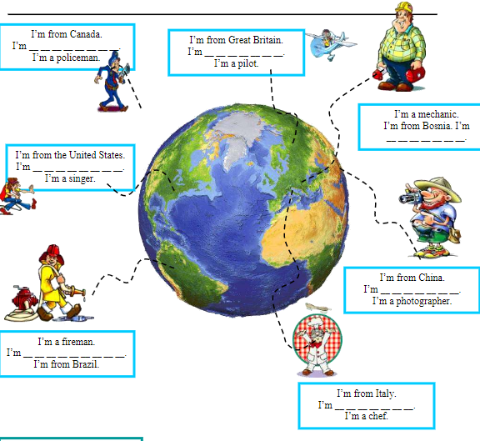

I’m from Canada. I’m **Canadian**. I’m a policeman

I’m from Great Britain. I’m **British**. I’m a pilot.

I’m a mechanic. I’m from Bosnia. I’m **Bosnian**.

I’m from the United States. I’m **American**. I’m a singer.

I’m from China. I’m **Chinese**. I’m a photographer.

I’m a fireman. I’m **Brazilian**. I’m from Brazil.

I’m from Italy. I’m **Italian**. I’m a chef.

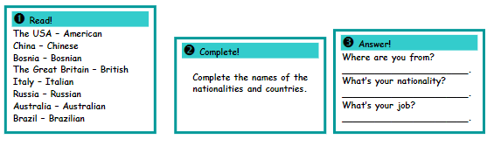

# 3.

Where are you from? **Brazil**.

What’s your nationality? **Brazilian**.

What’s your job? **I am a student**.

# 4.

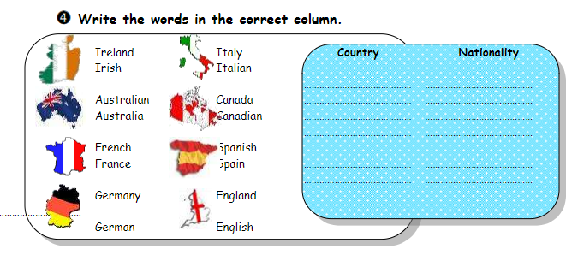

### Country: **Ireland, Australia, France, Germany, Italy, Canada, Spain, England**.

### Nationality: **Irish, Australian, French, German, Italian, Canadian, Spanish, English.**